SIMATS ENGINEERING
ASSESSMENT TOOL 1

COURSE NAME: Database Management Systems
COURSE CODE: CSA05

COURSE OUTCOME COVERED

CO2: Apply the relational model, relational algebra, SQL query structures, and views to solve database querying and data manipulation problems. (BL3, BL6)

Activity Tool : Analytical Problem Solving (High)
Assessment Tool Weightage: 35%

Dr

QUESTIONS Total Marks: 50
Q.No | Question | Bloom's Level | Marks
1 | Apply relational algebra operations (σ, π, ∪, -, ×, ⋈) on the given Employee and Department relations to retrieve required records. | BL3 – Apply | 5
2 | Write SQL DDL statements to create STUDENT(SID, Name, DOB, DeptID) and DEPARTMENT(DeptID, DeptName) tables with all appropriate constraints. | BL3 – Apply | 5
3 | Formulate SQL queries using GROUP BY, HAVING, and aggregate functions (COUNT, SUM, AVG, MAX, MIN) on a given Sales dataset. | BL3 – Apply | 5
4 | Write a correlated sub-query to find employees earning more than the average salary of their own department. | BL3 – Apply | 5
5 | Apply all types of JOIN operations (INNER, LEFT OUTER, RIGHT OUTER, FULL OUTER, CROSS) on Employee and Project tables. | BL3 – Apply | 5
6 | Create a view 'DeptSalaryView' that displays department name, total employees, and average salary. Write a query on this view. | BL6 – Create | 5
7 | Construct a relational algebra expression for the following: Find names of students who are enrolled in all courses offered. | BL6 – Create | 5
8 | Write SQL DML statements (INSERT, UPDATE, DELETE) with integrity constraint enforcement for a given scenario. | BL3 – Apply | 5
9 | Apply tuple relational calculus to express a query: Find all employees who work in the 'IT' department and earn more than 50000. | BL3 – Apply | 5
10 | Design a relational schema for an Airline Reservation System and write 5 SQL queries demonstrating joins, sub-queries, and views. | BL6 – Create | 5

Code of Conduct:

I S. Sayed Sahil(192525397)(Name / Reg No) certify that this submission is my original work and that I have adhered to the guidelines specified for this assessment.
I understand that any violation of academic integrity rules will result in disciplinary action.
s.sayed sahil
Signature of the student:

RUBRICS FOR CALCULATION:

Numerical Problems
Criteria | Weightage | Level 4 (Exemplary) | Level 3 (Proficient) | Level 2 (Developing) | Level 1 (Beginning)
Problem Understanding | 20% | Clearly interprets problem, identifies all parameters and requirements accurately | Understands problem with minor gaps | Partial understanding; misses key elements | Misinterprets or unable to understand problem
Method Selection | 20% | Selects most appropriate method/formula with strong justification | Selects correct method with minor errors | Inappropriate or partially correct method | Unable to select method
Solution Process | 25% | Logical, systematic steps with correct approach throughout | Mostly correct steps with minor mistakes | Disorganized steps; multiple errors | No clear process
Accuracy of Calculation | 20% | All calculations accurate; correct final answer | Minor calculation errors | Frequent errors; incorrect final answer | No valid calculations
Interpretation of Results | 15% | Clearly interprets results with units and engineering relevance | Basic interpretation with minor omissions | Limited or unclear interpretation | No interpretation

1Q)
create database companydb;
use companydb;

create table department(
deptid int primary key,
deptname varchar(30),
location varchar(30)
);

create table employee(
empid int primary key,
empname varchar(30),
salary int,
deptid int,
foreign key(deptid) references department(deptid)
);

insert into department values
(101,'hr','chennai'),
(102,'it','bangalore'),
(103,'finance','mumbai');

insert into employee values
(1,'rahul',45000,101),
(2,'sneha',60000,102),
(3,'arjun',55000,102),
(4,'priya',40000,103),
(5,'karan',70000,101);

select * from department;
select * from employee;

select * from employee where salary>50000;

select empname,salary from employee;

select deptid from employee
union
select deptid from department;

select deptid from department
where deptid not in(select deptid from employee);

select * from employee
cross join department;

select e.empid,e.empname,e.salary,d.deptname,d.location
from employee e
inner join department d
on e.deptid=d.deptid;

OUTPUT:
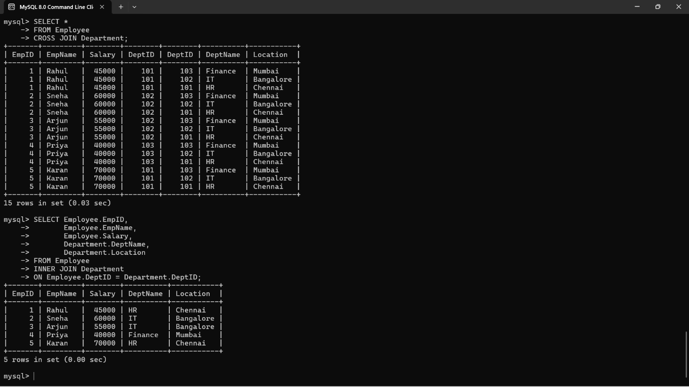
2Q)
create database collegedb;
use collegedb;

create table department(
deptid int primary key,
deptname varchar(30) not null unique
);

create table student(
sid int primary key,
name varchar(30) not null,
dob date not null,
deptid int,
foreign key(deptid) references department(deptid)
);

desc department;
desc student;

OUTPUT:

3Q)
create database salesdb;
use salesdb;

create table sales(
saleid int primary key,
productname varchar(30),
category varchar(20),
quantity int,
price int
);

insert into sales values
(1,'laptop','electronics',2,50000),
(2,'mouse','electronics',5,500),
(3,'keyboard','electronics',3,1000),
(4,'chair','furniture',4,3000),
(5,'table','furniture',2,7000),
(6,'pen','stationery',20,20),
(7,'book','stationery',10,150);

select * from sales;

select category,count(*) totalproducts
from sales
group by category;

select category,sum(quantity) totalquantity
from sales
group by category;

select category,avg(price) averageprice
from sales
group by category;

select category,max(price) highestprice
from sales
group by category;

select category,min(price) lowestprice
from sales
group by category;

select category,sum(quantity) totalquantity
from sales
group by category
having sum(quantity)>5;

OUTPUT :
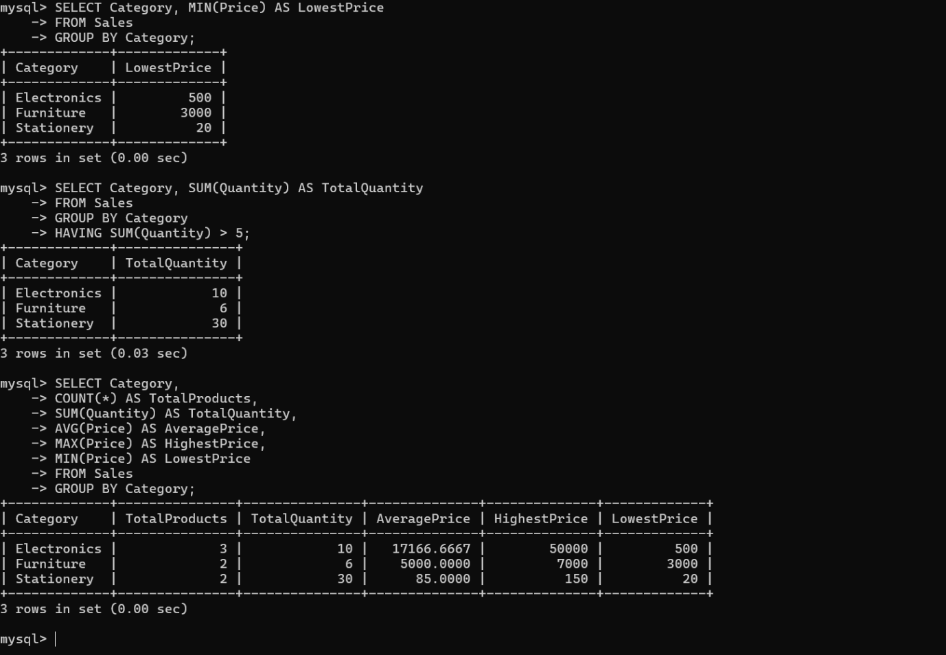

4Q)
use companydb;

select empid,
empname,
salary,
deptid
from employee e1
where salary>
(
select avg(salary)
from employee e2
where e1.deptid=e2.deptid
);

OUTPUT :
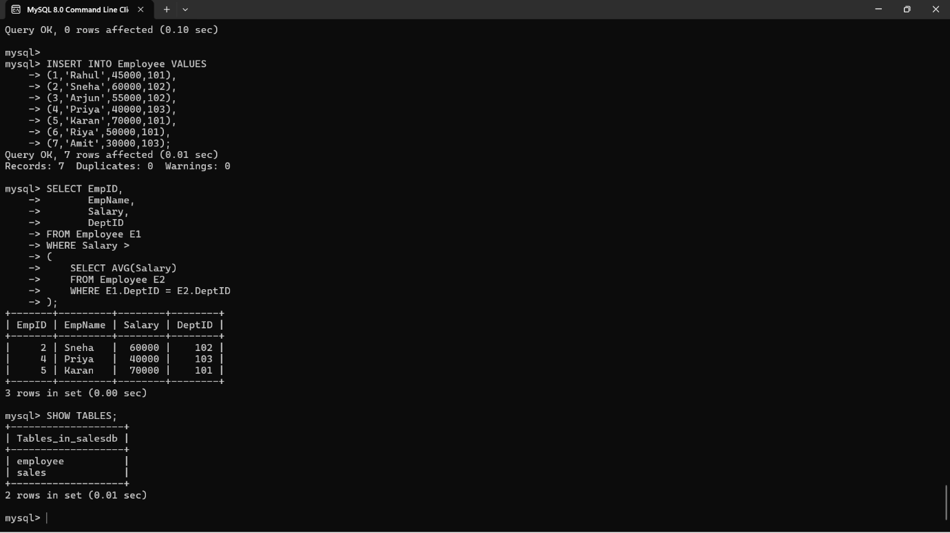
5Q)
use companydb;

create table project(
projectid int primary key,
projectname varchar(30),
deptid int
);

insert into project values
(1,'website',101),
(2,'mobile app',102),
(3,'payroll',103),
(4,'ai system',104);

select * from employee;
select * from project;

select e.empid,e.empname,p.projectname
from employee e
inner join project p
on e.deptid=p.deptid;

select e.empid,e.empname,p.projectname
from employee e
left join project p
on e.deptid=p.deptid;

select e.empid,e.empname,p.projectname
from employee e
right join project p
on e.deptid=p.deptid;

select e.empid,e.empname,p.projectname
from employee e
left join project p
on e.deptid=p.deptid

union

select e.empid,e.empname,p.projectname
from employee e
right join project p
on e.deptid=p.deptid;

select *
from employee
cross join project;

OUTPUT :
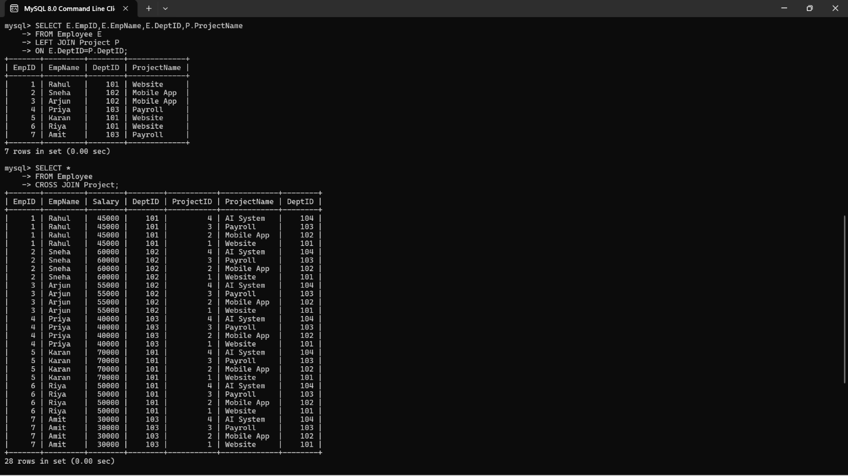
6Q)
use companydb;

create view deptsalaryview as
select d.deptname,
count(e.empid) as totalemployees,
avg(e.salary) as averagesalary
from department d
join employee e
on d.deptid=e.deptid
group by d.deptname;

select * from deptsalaryview;

OUTPUT :
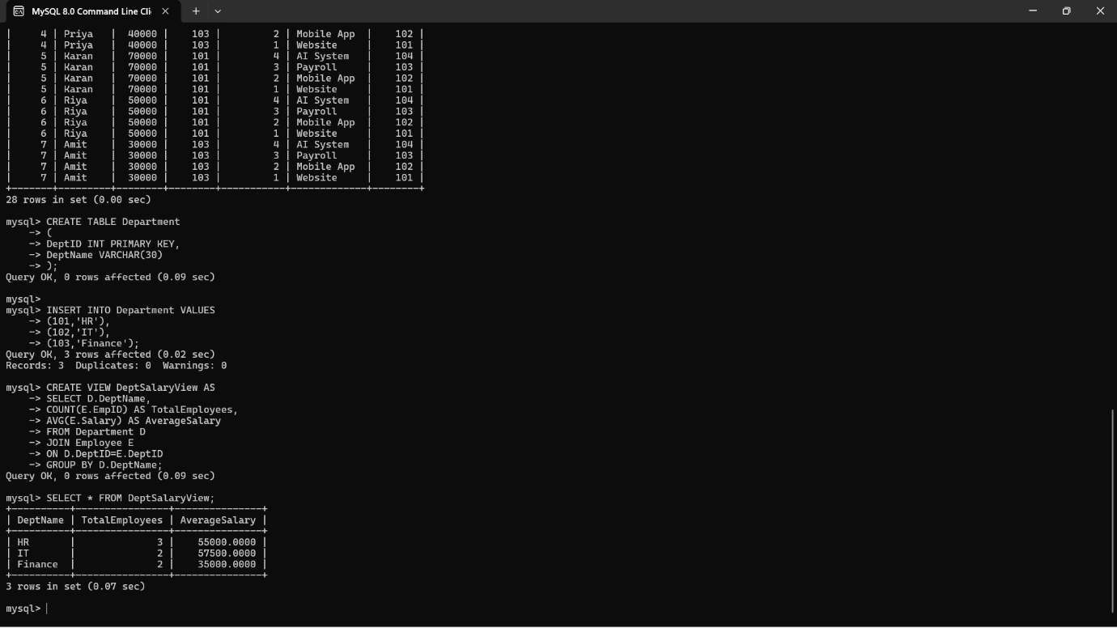
7Q)
create database studentdb;
use studentdb;

create table student(
sid int primary key,
name varchar(30)
);

create table course(
courseid int primary key,
coursename varchar(30)
);

create table enrollment(
sid int,
courseid int,
primary key(sid,courseid),
foreign key(sid) references student(sid),
foreign key(courseid) references course(courseid)
);

insert into student values
(1,'rahul'),
(2,'sneha'),
(3,'arjun');

insert into course values
(101,'dbms'),
(102,'java'),
(103,'python');

insert into enrollment values
(1,101),
(1,102),
(1,103),
(2,101),
(2,102),
(3,101);

OUTPUT :
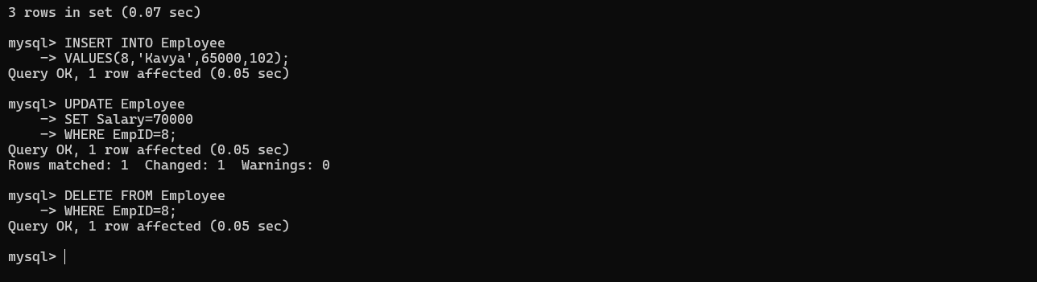

8Q)
use companydb;

insert into employee
values(6,'riya',50000,102);

select * from employee;

update employee
set salary=65000
where empid=6;

select * from employee;

delete from employee
where empid=6;

select * from employee;

OUTPUT :
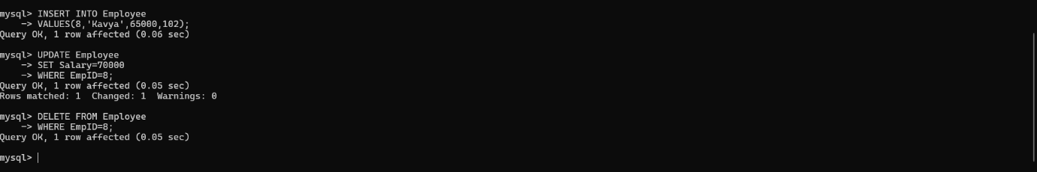
9Q)
use companydb;

create table department1(
deptid int primary key,
deptname varchar(30)
);

insert into department1 values
(101,'hr'),
(102,'it'),
(103,'finance');

select * from employee;
select * from department1;

select e.empid,
e.empname,
e.salary,
d.deptname
from employee e
join department1 d
on e.deptid=d.deptid
where d.deptname='it'
and e.salary>50000;

OUTPUT :
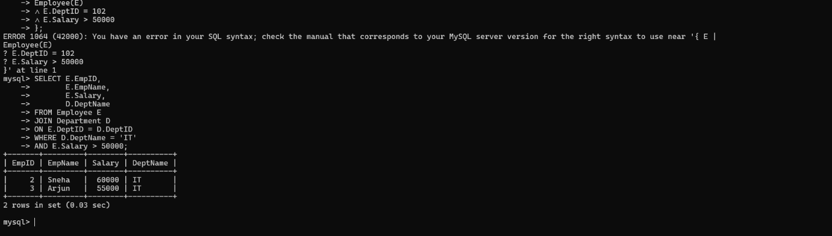
10Q)
create database airlinedb;
use airlinedb;

create table passenger(
passengerid int primary key,
passengername varchar(30),
phone varchar(15)
);

create table flight(
flightid int primary key,
flightname varchar(30),
source varchar(30),
destination varchar(30)
);

create table booking(
bookingid int primary key,
passengerid int,
flightid int,
journeydate date,
foreign key(passengerid) references passenger(passengerid),
foreign key(flightid) references flight(flightid)
);

insert into passenger values
(101,'rahul','9876543210'),
(102,'sneha','9876543211'),
(103,'arjun','9876543212'),
(104,'priya','9876543213');

insert into flight values
(201,'air india','chennai','delhi'),
(202,'indigo','bangalore','mumbai'),
(203,'spicejet','hyderabad','kolkata');

insert into booking values
(301,101,201,'2026-08-10'),
(302,102,202,'2026-08-11'),
(303,103,203,'2026-08-12'),
(304,104,201,'2026-08-13');

select * from passenger;
select * from flight;
select * from booking;

select passengername,flightname
from passenger p
join booking b
on p.passengerid=b.passengerid
join flight f
on b.flightid=f.flightid;

select passengername
from passenger
where passengerid in
(
select passengerid
from booking
);

select flightname,passengername
from flight f
join booking b
on f.flightid=b.flightid
join passenger p
on p.passengerid=b.passengerid;

create view flightbookingview as
select passengername,flightname
from passenger p
join booking b
on p.passengerid=b.passengerid
join flight f
on b.flightid=f.flightid;

select * from flightbookingview;

select flightid,
count(*) as totalbookings
from booking
group by flightid;

OUTPUT :
